

Darshan University

A Project Report on

**“College Management System”**

Under the subject

**Software Engineering (2301CS405)**

B. Tech, Semester – IV

Computer Science & Engineering Department

Submitted By

Student Name: Harshil Solanki Enrollment No : 23010101256

Academic Year (2024-2025)

|  |  |
| --- | --- |
| Internal Guide  Prof. R. B. Gondaliya  Darshan University | Dean-DIET  Dr. Gopi Sanghani  Darshan University |

**Computer Science & Engineering**

**Department**

**Darshan University**

**DECLARATION**

We hereby declare that the SRS, submitted along with the **Software Engineering** **(2301CS405)** for entitled **“College Management System”** submitted in partial fulfilment for the Semester-5 of **Bachelor Technology (B. Tech)** in **Computer Science and Engineering (CSE)** Departmentto Darshan University, Rajkot, is a record of the work carried out at **Darshan University, Rajkot** under the supervision of R. B. Gondaliya and that no part of any of report has been directly copied from any students’ reports, without providing due reference.

Harshil Solanki

(Student’s Signature)

Date: __________

**Computer Science & Engineering**

**Department**

**Darshan University**

**CERTIFICATE**

This is to certify that the SRS on **“College Management System” has** been satisfactorily prepared by **Solanki Harshil** (**23010101256**) under my guidance in the fulfillment of the course **Software Engineering (2301CS405)** work during the academic year 2024-2025.

Internal Guide Dean-DIET

Prof. R. B. Gondaliya Dr. Gopi Sanghani

Darshan University Darshan University

**ACKNOWLEDGEMENT**

I wish to express my sincere gratitude to my project guide Prof. R. B. Gondaliyaand all the faculty members for helping me through my project by giving me the necessary suggestions and advices along with their valuable co- ordination in completing this work.

I also thank my parents, friends and all the members of the family for their precious support and encouragement which they had provided in completion of my work. In addition to that, I would also like to mention the Darshan University personals who gave me the permission to use and experience the valuable resources required for the project from the University premises.

Thus, in conclusion to the above said, I once again thank the faculties and members of **Darshan University** for their valuable support in completion of the project.

Thanking You

**Solanki Harshil**

**ABSTRACT**

The College Management System is designed to streamline and automate various administrative and academic processes within an educational institution. It aims to enhance efficiency, accuracy, and accessibility of information for students, faculty, and administrative staff. This system offers a comprehensive solution for managing student admissions, course registrations, examination schedules, grading, and feedback. It also facilitates faculty management, including assigning roles, tracking performance, and updating course materials. For administrative staff, the system provides tools for managing finances, generating reports, and maintaining secure records. By integrating these functions into a single platform, the College Management System reduces manual workload, minimizes errors, and improves overall communication and collaboration within the institution.

This abstract provides a clear and concise overview of the system, highlighting its main features and benefits. If you need further details or adjustments, feel free to let me know!

**Table of Contents**

–

List of Figures ....................................................................................................................................................... I

List of Tables ....................................................................................................................................................... II

1 Introduction 1

1.1 Product perspective 1

1.2 Product features 1

1.2.1 There are three different users who will be using this product: 1

1.2.2 The features that are required for the Admin are: 1

1.2.3 The features that are required for the Student are: 1

1.2.4 The features that are required for the Faculty are: 1

1.3 Functional Requirement 2

1.3.1 Admin 2

1.3.2 Student 2

1.3.3 Faculty 2

1.4 Non-Functional Requirement 2

1.4.1 Usability: 2

1.4.2 Accuracy: 2

1.4.3 Availability: 2

1.4.4 Maintainability: 2

2 Design and Implementation Constraints 3

2.1 Use case diagram 3

2.2 Activity diagram and Swimlane diagram 4

2.3 Sequence diagram 7

2.4 State diagram 8

2.5 Class diagram 9

2.6 Data flow diagram 10

2.6.1 Context diagram (level-0) 10

2.6.2 DFD Level-1 10

2.6.3 DFD Level-2 11

3 External interface requirement (Screens) 12

3.1 Screen-1: Registration Form 12

3.2 Screen-2: Login Form 13

3.3 Screen-3: Add borrower book 14

4 Database design 15

4.1 List of Tables 15

5 Stories and Scenario 16

5.1 Story-1: Add New Book in Library Catalogue 16

5.1.1 Scenario# S1.1 16

5.1.2 Scenario# S1.2 16

5.1.3 Scenario# S1.3 16

5.2 Story-2: Search Book 17

5.3 Story-3: Manage due date for borrowed book 17

5.4 Story-4: Renew book 17

5.5 Story-5: Generate a report on book usage and availability 17

6 Test cases 18

7 References 22

**List of Figures**

Figure 2.1-1 Use case diagram for College Management System ...................................................................... 3

Figure 2.2-1 Activity diagram for Next Semester Registration ........................................................................... 4

Figure 2.2-2 Activity diagram for Examination ................................................................................................... 5

Figure 2.2-3 Swimlane diagram for Next Semester Registration ....................................................................... 6

Figure 2.3-1 Sequence diagram for Book Issue .................................................................................................. 7

Figure 2.4-1 State diagram of Book .................................................................................................................... 8

Figure 2.4-2 State diagram for Librarian ........................................................................................................... 8

Figure 2.5-1 Class diagram for Library management system ............................................................................. 9

Figure 2.6-1 Context diagram for Library management system ...................................................................... 10

Figure 2.6-2 DFD level-1 for Library management system ............................................................................... 10

Figure 2.6-3 DFD level-2 for Issue book ........................................................................................................... 11

Figure 3.1-1 Screen-1: Registration Form ........................................................................................................ 12

Figure 3.2-1 Screen-2: Login Form ................................................................................................................... 13

Figure 3.3-1 Screen-3: Add borrower book ...................................................................................................... 14

**I**

**List of Tables**

Table 3.1-1 Screen element of Registration form ............................................................................................ 12

Table 3.2-1 Screen element of Login form ....................................................................................................... 13

Table 3.3-1 Screen element of Add borrower book ......................................................................................... 14

Table 4.1-1 Table: Book .................................................................................................................................... 15

Table 4.1-2 Table: Borrower ............................................................................................................................. 15

Table 4.1-3 Table: Staff ..................................................................................................................................... 15

Table 4.1-4 Table: Student ............................................................................................................................... 15

**II**

# Introduction

## Product perspective

This project transforms the college management system into an online platform, making it easy to manage various tasks. Admins can handle branches, students, and faculty data, schedule exams, and manage attendance. Students can view grades, update profiles, check class schedules, upload assignments, give feedback, download study materials, and pay fees online. Faculty members can view records, upload content, check salaries, manage assignments, give grades, and respond to feedback. This system simplifies administrative and academic tasks, making everything more efficient and accessible.

## Product features

### There are three different users who will be using this product:

* Admin who will be handle the software.
* Student Accesses academic resources and personal profiles.
* Faculty course content and student assignments.

### The features that are required for the Admin are:

* New branch will be entered in database
* Any changes in branch should be updated in database.
* If University wants to remove branch for their upcoming year then removed from system
* New student data can be add in the database
* if New Faculty join then faculty data can be add in the database
* Admin can schedule exams
* Admin can Upload the feedback for Faculty, course and teaching assistance
* Admin is able to view the Attendance of Students and Staff
* Can Change the Attendance of any Student and Staff
* Assign courses to faculty members

### The features that are required for the Student are:

* can see their grade of the exam
* can view their profile
* can update their profile
* can see their class for the upcoming lectures
* can upload assignment given by faculty
* can give feedback on Faculty, Teaching assistance and Course • can download the study material uploaded by the faculty
* can Pay their fee using upi or netbanking.

### The features that are required for the Faculty are:

* can view their records
* can upload subject related content so that student can have benefit of it
* can check salary of till the join date
* login in their account
* can view the assignment upload by the student
* can give grade on student assignment
* can upload ppt and pdf
* can respond to feedback if necessary
* can delete their profiles

## Functional Requirement

### Admin

* Add Branch: New branch will be entered in database
* Update Branch: Any changes in branch should be updated in database.
* Remove Branch: If University wants to remove branch for their upcoming year then removed from system
* Add Student : New student data can be add in the database
* Add Faculty : if New Faculty join then faculty data can be add in the database
* Schedule Exams: Admin can schedule exams
* Upload Feedback: Admin can Upload the feedback for Faculty, course and teaching assistance
* View Attendance : Admin is able to view the Attendance of Students and Staff
* Update Attendance: Can Change the Attendance of any Student and Staff
* Course Assignment: Assign courses to faculty members

### Student

* View Grade: Student can see their grade of the exam
* View Student Profile : Student Can view their profile
* Update Profile: Student can update their profile
* View Class : Student can see their class for the upcoming lectures
* Assignment Upload : Student can upload assignment given by faculty
* Give Feedback : Student can give feedback on Faculty, Teaching assistance and Course
* Download Content : Student can download the study material uploaded by the faculty
* Fee Payment : Student can Pay their fee using upi or netbanking

### Faculty

* Faculty Record : Faculty can view their records
* Upload Video : Faculty can upload subject related content so that student can have benefit of it
* Check Salary : Faculty can check salary of till the join date
* Login : login in their account
* Assignment view : Faculty can view the assignment upload by the student
* Give Grade : Faculty can give grade on student assignment
* Upload study material : Faculty can upload ppt and pdf
* Response to Feedback : Faculty and admin can respond to feedback if necessary
* Profile Deletion: Faculty members can delete their profile

## Non-Functional Requirement

### Usability:

• The UI should be simple enough for everyone to understand and get the relevant information without any special training. Different languages can be provided based on the requirements.

### Accuracy:

• The data stored about the books and the fines calculated should be correct, consistent, and reliable.

### Availability:

• The System should be available for the duration when the library operates and must be recovered within an hour or less if it fails. The system should respond to the requests within two seconds or less.

### Maintainability:

• The software should be easily maintainable and adding new features and making changes to the software must be as simple as possible. In addition to this, the software must also be portable.

# Design and Implementation Constraints

## Use case diagram

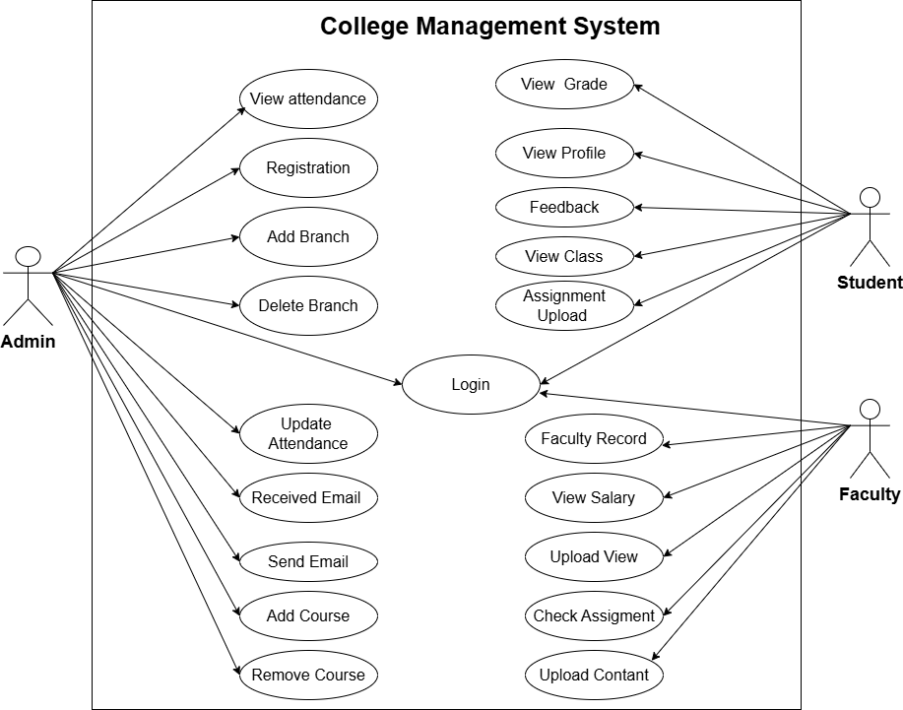

*Figure 2.1-1 Use case diagram for College Management System*

## Activity diagram and Swimlane diagram

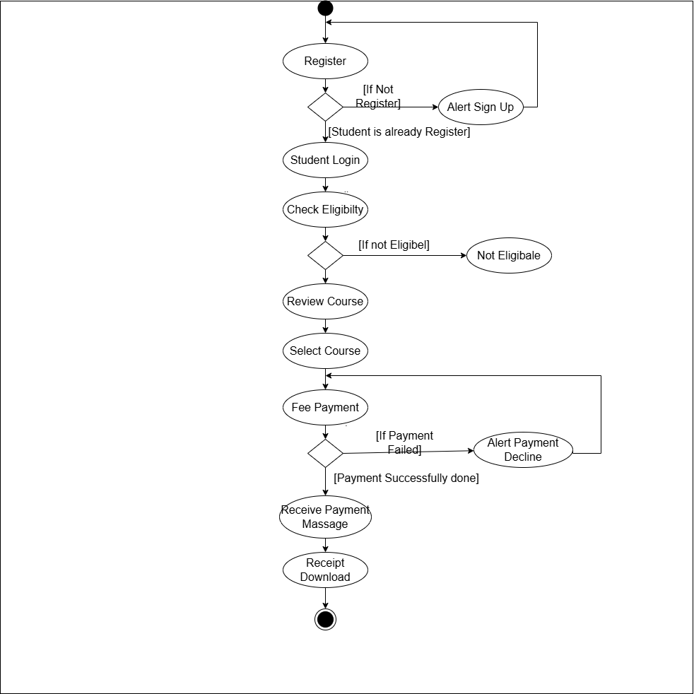

*Figure 2.2-1 Activity diagram for Next Semester Registration*

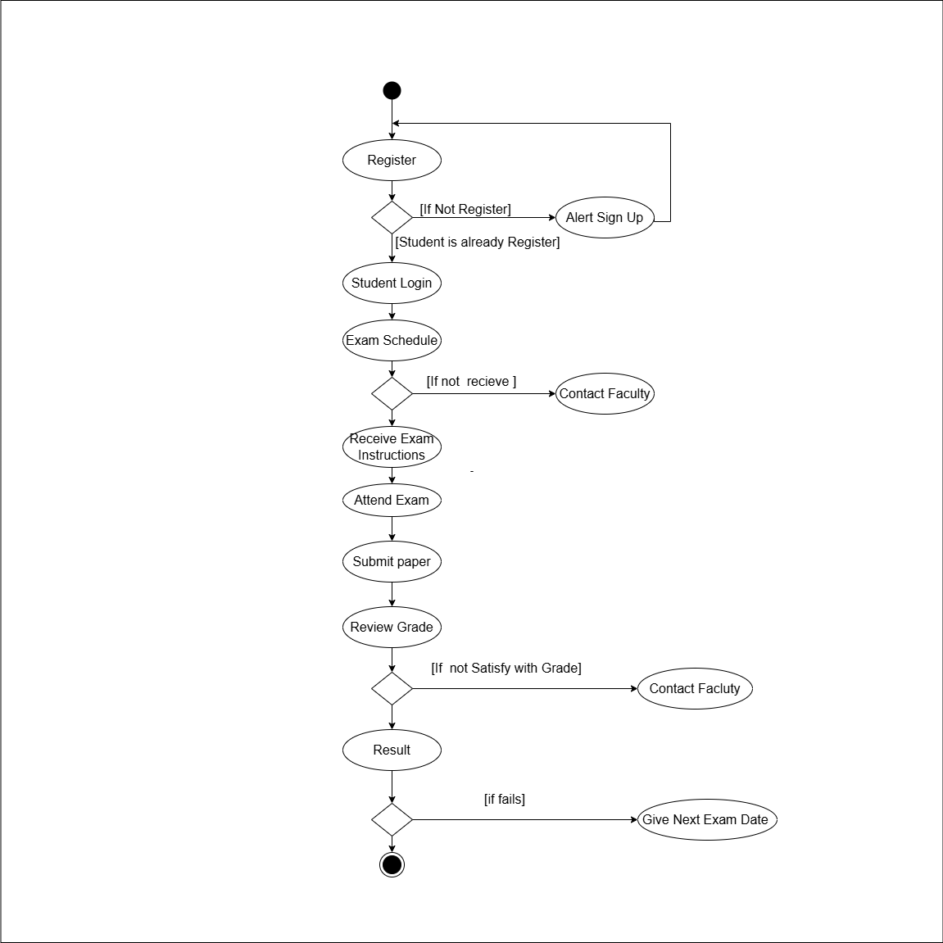

*Figure 2.2-2 Activity diagram for Examination*

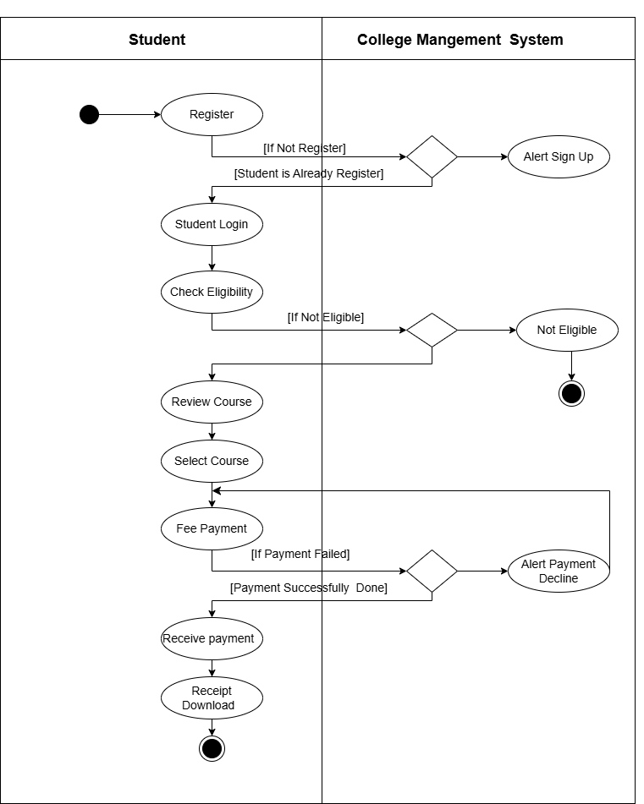

*Figure 2.2-3 Swimlane diagram for Next Semester Registration*

## Sequence diagram

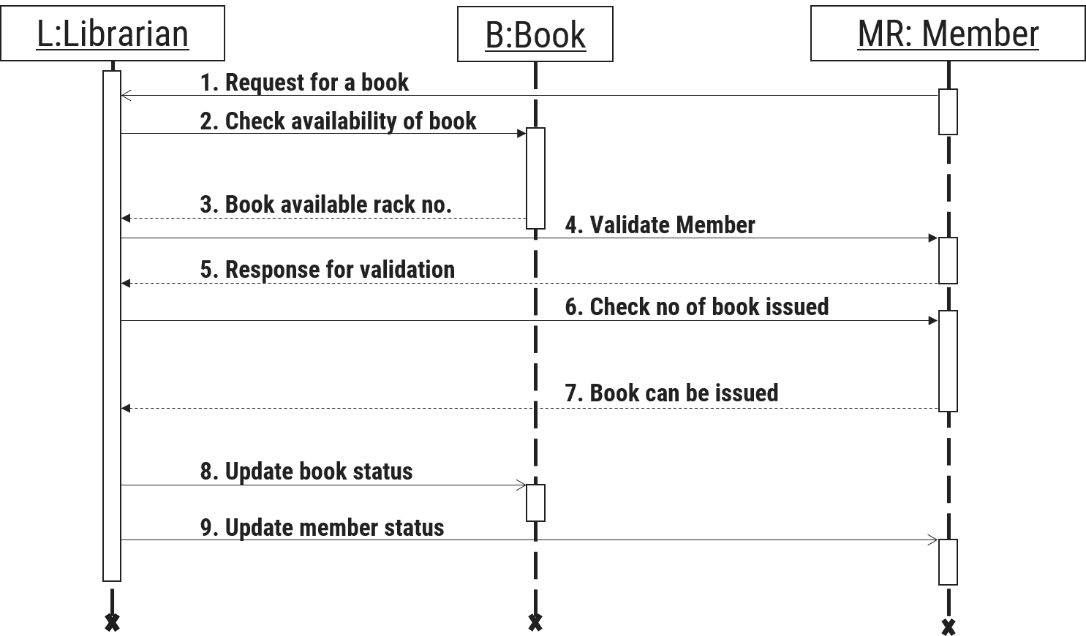

*Figure 2.3-1 Sequence diagram for Book Issue*

## State diagram

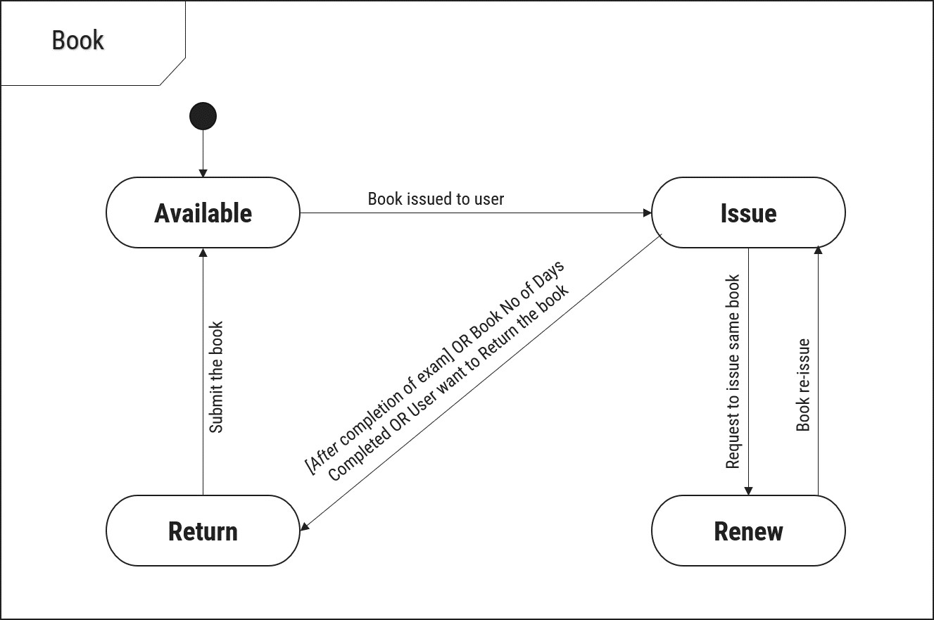

*Figure 2.4-1 State diagram of Book*

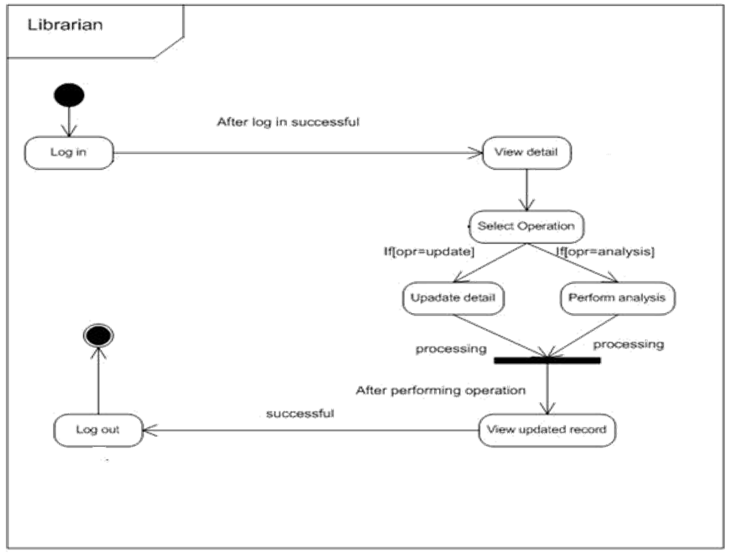

*Figure 2.4-2 State diagram for Librarian*

## Class diagram

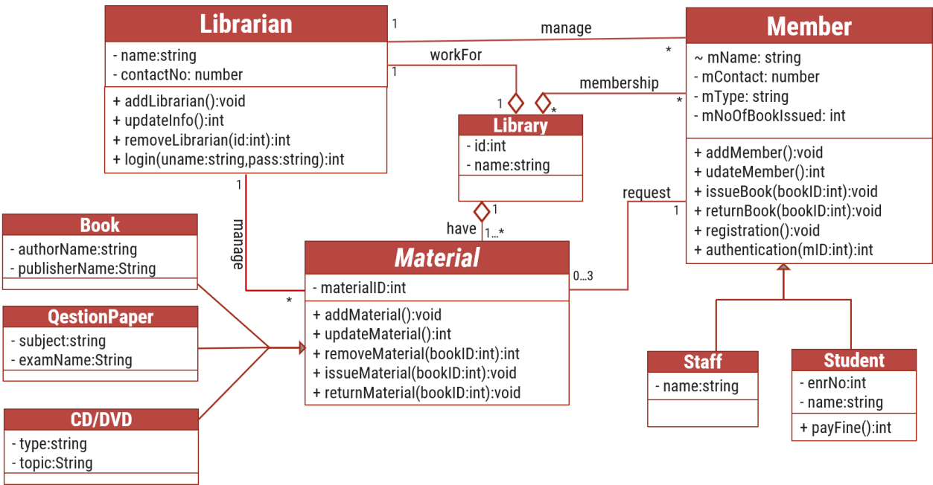

*Figure 2.5-1 Class diagram for Library management system*

## Data flow diagram

### Context diagram (level-0)

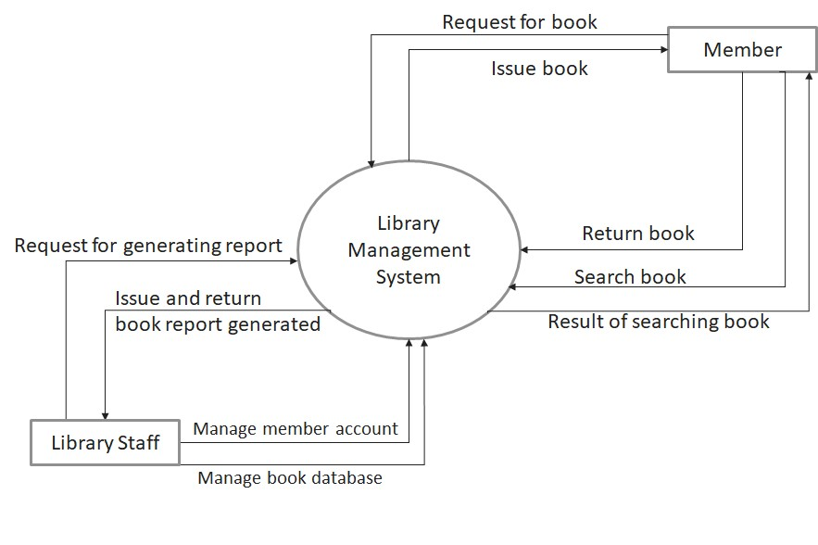

*Figure 2.6-1 Context diagram for Library management system*

### DFD Level-1

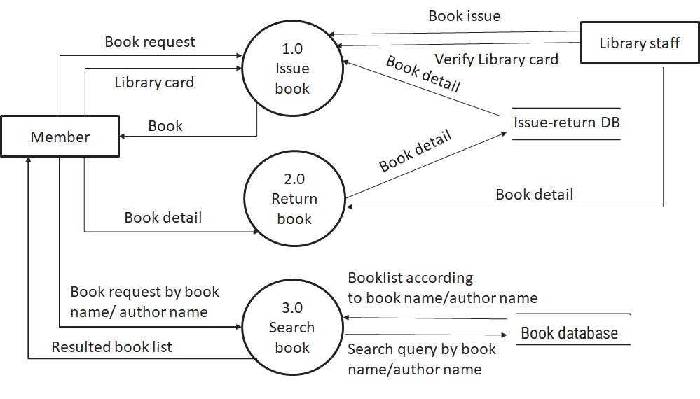

*Figure 2.6-2 DFD level-1 for Library management system*

### DFD Level-2

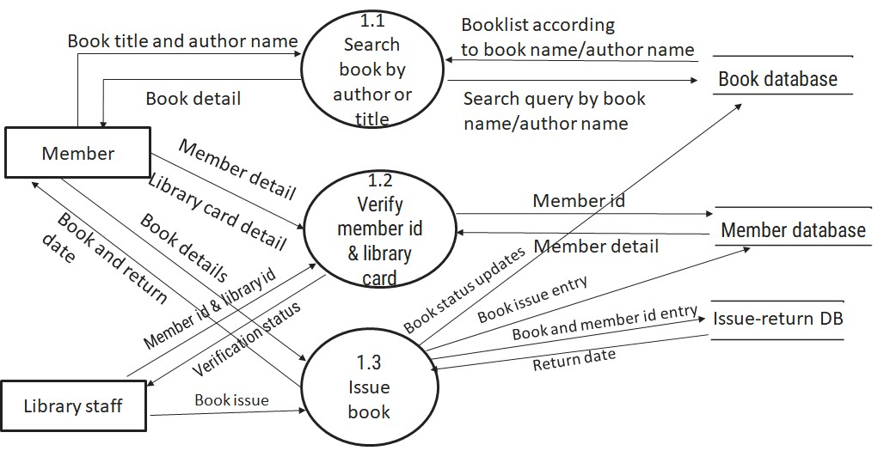

*Figure 2.6-3 DFD level-2 for Issue book*

# External interface requirement (Screens)

## Screen-1: Registration Form

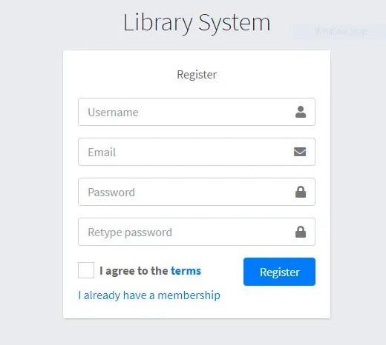

*Figure 3.1-1 Screen-1: Registration Form*

**Purpose:** This form will allow the target end-users to register in the system. To register, the following information will be encoded in the system.

*Table 3.1-1 Screen element of Registration form*

|  |  |  |  |  |  |
| --- | --- | --- | --- | --- | --- |
| **Sr.** | **Screen Element** | **Input Type** | **O/M** | **1/N** | **Description** |
| **1** | Username | Textbox | M | 1 | Username field should be editable and accept the Username. |
| **2** | Email | Textbox | M | 1 | Email field should be editable and accept the email with proper format. |
| **3** | Password | Password | M | 1 | Password field should be editable and accept the password and display as star or dot. |
| **4** | Retype password | Password | M | 1 | Retype Password field should be editable and accept the password and display as star or dot. |
| **5** | I agree to the terms | Checkbox | M | 1 | Checkbox for accepting terms and condition. |
| **6** | I already have a membership | Link | ------ | ------ | Link for navigate to login page for registered user. |
| **7** | Register | Button | ------ | ------ | Register is a button for store the entered data into database. |

## Screen-2: Login Form

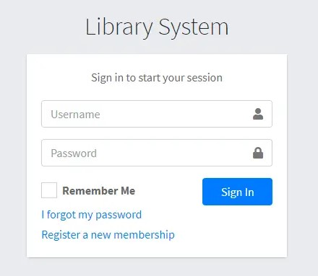

*Figure 3.2-1 Screen-2: Login Form*

**Purpose:** This form will be used by the system’s users to access records and features of the system. The users will input the correct combination of their username and password to be able to login to the system.

*Table 3.2-1 Screen element of Login form*

|  |  |  |  |  |  |
| --- | --- | --- | --- | --- | --- |
| **Sr.** | **Screen Element** | **Input Type** | **O/M** | **1/N** | **Description** |
| **1** | Username | Textbox | M | 1 | Username field should be editable and accept the Username. |
| **2** | Password | Password | M | 1 | Password field should be editable and accept the password and display as star or dot. |
| **3** | Remember Me | Checkbox | M | 1 | Saving login credentials through remember me checkbox |
| **4** | I forgot my  password | Link | ------ | ------ | Link for navigate to Forgot password page for allows users to recover password. |
| **5** | Register a new membership | Link | ------ | ------ | Link for navigate to membership registration. |
| **6** | Sign in | Button | ------ | ------ | Login button navigates to another page even if valid login credentials. |

## Screen-3: Add borrower book

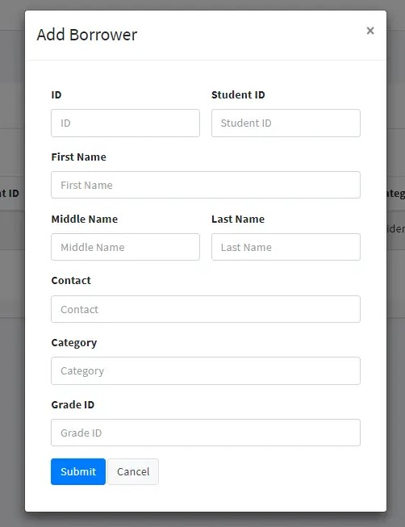

*Figure 3.3-1 Screen-3: Add borrower book*

**Purpose:** This module will allow the system administrator to add, edit, update or delete borrowers of book. The admin can add borrower information and manage it.

*Table 3.3-1 Screen element of Add borrower book*

|  |  |  |  |  |  |
| --- | --- | --- | --- | --- | --- |
| **Sr.** | **Screen Element** | **Input Type** | **O/M** | **1/N** | **Description** |
| **1** | Borrower ID | Textbox | M | 1 | Borrower ID field should be editable and fill autogenerated Borrower ID. |
| **2** | Student ID | Textbox | M | 1 | Student ID field should be editable and accept Student barcode id. |
| **3** | First Name | Textbox | M | 1 | First Name field should be editable and accept only string as a borrower first name. |
| **4** | Middle Name | Textbox | O | 1 | Middle Name field should be editable and accept only string as a borrower middle name. |
| **5** | Last Name | Textbox | M | 1 | Last Name field should be editable and accept only string as a borrower last name. |
| **6** | Contact | Textbox | M | 1 | Contact field should be editable and accept only 10-digit mobile number. |
| **7** | Grade Id | Textbox | O | 1 | Auto fetch detail from the database if proper student id is entered. |
| **8** | Submit | Button | ----- | ----- | Submit is a button for store the entered data into database. |
| **9** | Cancel | Button | ----- | ----- | Cancel is a button for close add borrower dialog. |

# Database design

## List of Tables

* Book
* Borrower
* Student
* Staff

*Table 4.1-1 Table: Admin*

|  |  |  |  |  |
| --- | --- | --- | --- | --- |
| **Column** | **Data Type** | **Null** | **Keys & Constrains** | **Default Value & Description** |
| **AdminID** | int | NN | PK (Auto Increment) |  |
| **Name** | varchar(100) | NN |  |  |
| **Email** | varchar(100) | AN |  |  |
| **Phone_no** | int | NN |  |  |
| **Role** | varchar(50) | AN |  |  |
| **FacultyID** | int | NN | FK | Reference of Faculty table |

*Table 4.1-2 Table: Course*

|  |  |  |  |  |
| --- | --- | --- | --- | --- |
| **Column** | **Data Type** | **Null** | **Keys & Constrains** | **Default Value & Description** |
| **CourseID** | int | NN | PK (Auto Increment) |  |
| **CourseCode** | int | NN |  |  |
| **DepartmentId** | int | NN | FK | Reference of Department table |
| **CourseName** | Varchar(100) | NN |  |  |
| **description** | Varchar(1000) | AN |  |  |

*Table 4.1-3 Table:* Faculty

|  |  |  |  |  |
| --- | --- | --- | --- | --- |
| **Column** | **Data Type** | **Null** | **Keys & Constrains** | **Default Value & Description** |
| **FacultyID** | int | NN | PK (Auto Increment) |  |
| **FacultyName** | varchar(100) | NN |  |  |
| **Email** | varchar(100) | AN |  |  |
| **Office** | Varchar(100) | AN |  |  |

*Table 4.1-4 Table: Student*

|  |  |  |  |  |
| --- | --- | --- | --- | --- |
| **Column** | **Data Type** | **Null** | **Keys & Constrains** | **Default Value & Description** |
| **StudentID** | int | NN | PK (Auto Increment) |  |
| **StudentName** | varchar(100) | AN |  |  |
| **Gender** | varchar(100) | AN |  |  |
| **DOB** | DateTime | AN |  |  |
| **Department** | varchar(100) | AN |  |  |
| **Contact** | number(10,0) | AN |  |  |
| **DepartmentID** | int | NN | FK | Reference of Department table |

*Table 4.1-5Table: Department*

|  |  |  |  |  |
| --- | --- | --- | --- | --- |
| **Column** | **Data Type** | **Null** | **Keys & Constrains** | **Default Value & Description** |
| **DepartmentID** | int | NN | PK (Auto Increment) |  |
| **DepartmentName** | varchar(100) | AN |  |  |
| **HeadOfDepartment** | varchar(100) | NN | FK | Reference of the Faculty table |

# Stories and Scenario

## Story-1: Add New Book in Library Catalogue

|  |  |  |
| --- | --- | --- |
| *Story #* ***S1*** | **:** | As a **Student**, I want to **view my grade for the exam** So that **I can keep track of my performance**. |
| **Priority** | **:** | Medium |
| **Estimate** | **:** | L |
| **Reason** | **:** | Students need to easily access their grades for exam performance tracking. |

### Scenario# S1.1

|  |  |  |
| --- | --- | --- |
| *Scenario#* ***S1.1*** | **:** | Viewing Exam Grade |
| **Prerequisite** | **:** | The student is logged into the student portal of the system. |
| **Acceptance**  **Criteria** | **:** | **Given**: The student is on the student dashboard and has completed at least one exam.  **When**: The student selects the "View Grades" option from the dashboard. The system retrieves and displays the student’s exam grades.  **Then**: The system successfully displays the student’s exam grades along with relevant details, such as the exam name, grade, and any feedback from the instructor. The student is able to see their performance in a clear and understandable format. |

### Scenario# S1.2

|  |  |  |
| --- | --- | --- |
| *Scenario#* ***S1.2*** | **:** | **Viewing Exam Grade with Error in Data** |
| **Prerequisite** | **:** | : The student is logged into the student portal of the system. |
| **Acceptance**  **Criteria** | **:** | **Given**: The student is on the student dashboard and their exam grade has been entered into the system, but an error occurred while processing the data  **When**: The student selects the "View Grades" option from the dashboard. The system attempts to retrieve and display the student's exam grade but encounters a data issue.  **Then**: The system displays a message indicating that there was an error retrieving the exam grade. The student is informed to try again later or contact support for assistance. |

### Scenario# S1.3

|  |  |  |
| --- | --- | --- |
| *Scenario#* ***S1.3*** | **:** | **Viewing Exam Grade After Re-evaluation** |
| **Prerequisite** | **:** | The student is logged into the student portal of the system, and their exam has been re-evaluated. |
| **Acceptance**  **Criteria** | **:** | **Given**: The student is on the student dashboard, and their exam grade has been re-evaluated after an initial grading.  **When**: The student selects the "View Grades" option from the dashboard. The system retrieves and displays the updated exam grade and any associated feedback from the instructor.  **Then**: The system successfully displays the updated exam grade along with the re-evaluation details, including any feedback or changes from the instructor. |

## Story-2: View Faculty Member's Professional Records

|  |  |  |
| --- | --- | --- |
| *Story #* ***S2*** | : | As a **Faculty Member**, I want to **view my records** So that **I can keep track of my professional details**. **Priority**: High |
| **Priority** | **:** | High |
| **Estimate** | **:** | M |
| **Reason** | **:** | Faculty members need to have easy access to their records for verification and updating purposes. |

### Scenario# S1.1

|  |  |  |
| --- | --- | --- |
| *Scenario#* ***S1.1*** | **:** | Viewing Faculty Member's Professional Records |
| **Prerequisite** | **:** | The faculty member is logged into the faculty portal of the system. |
| **Acceptance**  **Criteria** | **:** | **Given**: The faculty member is on the faculty dashboard, but some of their professional records (e.g., qualifications, experience) are incomplete or missing.  **When**: The faculty member selects the "View Professional Records" option from the dashboard. The system attempts to retrieve the faculty member’s professional records but encounters missing or incomplete data.  **Then**: The system displays a message indicating that certain records are incomplete or missing. The faculty member is prompted to update their records or contact the relevant department to complete the information. |

### Scenario# S1.2

|  |  |  |
| --- | --- | --- |
| *Scenario#* ***S1.2*** | **:** | **Viewing Faculty Member's Professional Records After Update** |
| **Prerequisite** | **:** | : The faculty member is logged into the faculty portal of the system, and their professional records have been updated (e.g., new publications, certifications). |
| **Acceptance**  **Criteria** | **:** | **Given**: The faculty member is on the faculty dashboard, and their professional records have been updated since the last view.  **When**: The faculty member selects the "View Professional Records" option from the dashboard. The system retrieves and displays the updated professional records and details.  **Then**: The system successfully displays the updated professional records, including new information such as recent publications, updated qualifications, or job responsibilities. The faculty member is able to review the most recent version of their professional details. |

### Scenario# S1.3

|  |  |  |
| --- | --- | --- |
| *Scenario#* ***S1.3*** | **:** | **Viewing Faculty Member's Professional Records with Error in Data** |
| **Prerequisite** | **:** | The faculty member is logged into the faculty portal of the system, and their professional records have been entered into the system, but there is an error (e.g., system glitch, incorrect data). |
| **Acceptance**  **Criteria** | **:** | **Given**: The faculty member is on the faculty dashboard, and their professional records have been stored in the system.  **When**: the faculty member clicks on "View Professional Records," but the system encounters a problem with the data,  **Then**: the system shows an error message and asks the faculty member to contact support or try again later. They are also given an option to report the issue for further investigation. |

## Story-3: ****Manage University Data and Records****

|  |  |  |
| --- | --- | --- |
| *Story #* ***S3*** | **:** | **As an Admin**, I want to **manage the university's data** So that **I can maintain accurate records and ensure smooth operations**. |
| **Priority** | **:** | High |
| **Estimate** | **:** | M |
| **Reason** | **:** | The admin needs to efficiently manage all aspects of the university data, including branches, students, faculty, exams, attendance, feedback, and assignments. |

### Scenario# S1.1

|  |  |  |
| --- | --- | --- |
| *Scenario#* ***S1.1*** | **:** | **Adding a New Branch to the Database** |
| **Prerequisite** | **:** | The admin is logged into the university management system. |
| **Acceptance**  **Criteria** | **:** | **Given**: The admin is on the branch management page of the system.  **When**: The admin selects the "Add New Branch" option. The admin enters the required details for the new branch (e.g., name, code, location).The admin clicks the "Save" button.  **Then**: The system successfully adds the new branch to the database. The admin receives a confirmation message that the branch has been successfully added. |

### Scenario# S1.2

|  |  |  |
| --- | --- | --- |
| *Scenario#* ***S1.2*** | **:** | **Updating Branch Information in the Database** |
| **Prerequisite** | **:** | The admin is logged into the university management system, and a branch already exists in the database. |
| **Acceptance**  **Criteria** | **:** | **Given**: The admin is on the branch management page, and the details of an existing branch need to be updated.  **When**: The admin selects the branch to be updated. The admin modifies the branch. The admin clicks the "Update" button to save the changes.  **Then**: The system successfully updates the branch information in the database. The admin receives a confirmation message that the branch has been updated. |

### Scenario# S1.3

|  |  |  |
| --- | --- | --- |
| *Scenario#* ***S1.3*** | **:** | Scheduling an Exam for Students |
| **Prerequisite** | **:** | The admin is logged into the university management system. |
| **Acceptance**  **Criteria** | **:** | **Given**: The admin is on the exam scheduling page and has the necessary exam details.  **When**: The admin selects the "Schedule Exam" option. The admin enters the required exam details. The admin clicks the "Schedule" button.  **Then**: The system successfully schedules the exam and saves the exam details in the database. The admin receives a confirmation message that the exam has been scheduled. |

# Test cases

|  |  |  |  |
| --- | --- | --- | --- |
| **Project Name:** | **EMI Calculator** | **Test Designed by:** | **P. U. Jadeja** |
| **Module Name:** | **Login** | **Test Designed date:** | 01-10-2023 |
| **Release Version:** | **1.0** | **Test Executed by:** | **R. B. Gondaliya** |
|  |  | **Test Execution date:** | 15-01-2023 |

|  |  |  |  |  |
| --- | --- | --- | --- | --- |
| **Pre-condition**: **Web application should be accessible** | | | |  |
| **Test Case ID** | **Test Title** | **Test Type** | **Description** | **Test Case ID** |
| **TC_001** | Login to web application with valid credential | Functional | Login to Library management system web application through valid credential | TC_001 |
| **TC_002** | Login to web application with  invalid credential | Functional | Login to Library management system web application through invalid credential | TC_002 |
| **TC_003** | Varify login page elements | GUI | varify that all elements are availabe on login page | TC_003 |

|  |  |
| --- | --- |
| Test Case Title | Login to web application with valid credential |
| Test Type | Functional |
| Test Priority | High |
| Pre-condition | Web application should be accessible |

|  |  |  |  |  |  |  |  |
| --- | --- | --- | --- | --- | --- | --- | --- |
| Test Step | Test Case Description | Expected Result | Actual Result | Status | Comment | Data | BUG ID |
| 1 | Access Web application URL | The site  launched properly | Site launched successfully | Pass |  | [https://accounts. google.com/Ser viceLogin](https://accounts.google.com/ServiceLogin) |  |
| 2 | Enter valid Username  in username  field | Username field should be editable and accept the  Username | Username input accepted | Pass |  | Username: Rbgondaliya@ gmail.com |  |
| 3 | Enter valid Password in Password  field | Password field should be editable and accept the password and display as star or dot | Password input displayed in dot and  accepted | pass |  | Password: rbgondaliya |  |
| 4 | Enter valid captcha  code in  captch field | Captch field should editable and accept captcha and captcha is case sensitive | Captcha input accepted | Pass | Step require d when human  action validati on | get captcha from image which is near by captcha  field |  |
|  |  |  |  |  | perfor m |  |  |
| 5 | Click on  login button | User should login into site and navigated to dashboard | User navigated to dashboard and  username should br display in top of the right side. | pass |  |  |  |

|  |  |
| --- | --- |
| Test Case Title | Login to web application with invalid credential |
| Test Type | Functional |
| Test Priority | Medium |
| Pre-condition | Web application should be accessible |

|  |  |  |  |  |  |  |  |
| --- | --- | --- | --- | --- | --- | --- | --- |
| Test Step | Test Case Description | Expected Result | Actual Result | Status | Comment | Data | Bug ID |
| 1 | Verify that User is not able to Login with  invalid  Username and  invalid  Password | Should be display an error message enter wrong username  or password | Display an error of wrong username and password | Pass |  |  |  |
| 2 | Verify that User is not able to Login with Valid Username and  invalid  Password | Should be display an  error message enter wrong password | Display an error of wrong password | Pass |  |  |  |
| 3 | Verify that User is not able to Login with | Should be display an error message | Display an error  Username not found | Pass |  |  |  |
|  | invalid  Username and Valid Password | User not found |  |  |  |  |  |
| 4 | Verify that User is not able to Login with  blank  Username  or  Password | Set required field  validation  message  for  Username and Password | Display an error of wrong username and password | Fail | Not performa  a validation  function  fix it |  | Bug_002 |

|  |  |
| --- | --- |
| Test Case Title | Varify login page elements |
| Test Type | GUI |
| Test Priority | Medium |
| Pre-condition | Web application should be accessible |

|  |  |  |  |  |  |  |  |
| --- | --- | --- | --- | --- | --- | --- | --- |
| Test Step | Test Case  Description | Expected Result | Actual Result | Status | Comment | Data | Bug  ID |
| 1 | Launch application with the  given url | The site launched properly | Site launched successfully | Pass |  | [https://accounts.googl e.com/ServiceLogin](https://accounts.google.com/ServiceLogin) |  |
| 2 | Verify that the login screen contains elements  such as  Username,  Password,  Sign in  button,  Remember password check box, Forgot password link, and Create an account link. | All listed control displayed  properly  on the  page | Login page loaded successfully | Pass |  |  |  |
| 3 | Verify that cursor is focused on  “Usernam  e” text box on the  page load | Cursor is  focused  in  Usernam  e textbox | Cursor  focus in Username textbox | Pass |  |  |  |
| 4 | Verify that tab functionali  ty is  working properly or not | When tab pressed cursor  move in  next control | Cursor moving in next control | Pass |  |  |  |
| 5 | Verify that all the fields such as  Username, Password has a valid  placeholde  r | All text  fields have proper placehold er | All text fields have proper placeholder | Pass |  |  |  |
| 6 | Verify that the labels float  upward when the text field is in focus or filled (In case of  floating label) | When field is focused or filled, label display on top of the  filled | When field is focus or filled, label display on top of the  filled | Pass | step required when  fields with floating label |  |  |
| 7 | verify that forgot password  link  working properly | when click on forgot password load forgot passworg page | forgot  password link not  working | Fail |  |  |  |

# References

* http://www.w3schools.com/html/html_intro.asp
* https://www.w3schools.com/php/default.asp
* https://www.javatpoint.com/uml